Ejercicio 1 a+b?c*

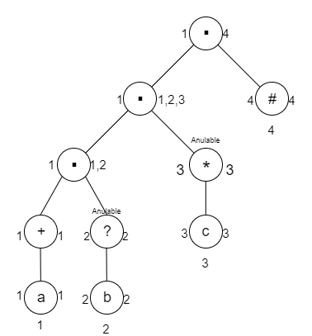

|  |  |  |  |  |
| --- | --- | --- | --- | --- |
|  | a | b | c | FDC |
| A = 1 | B = 1,2,3,4 | - | - | - |
| B = 1,2,3,4 | B = 1,2,3,4 | C = 3,4 | C = 3,4 | Acepto |
| C = 3,4 | - | - | C = 3,4 | Acepto |

|  |  |
| --- | --- |
|  | Follow |
| 1 – a | 1,2,3,4 |
| 2 – b | 3,4 |
| 3 – c | 3,4 |
| 4 – # |  |

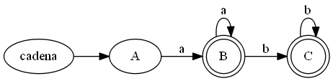

Ejercicio 2 ((a|b)* | (ab)*)?

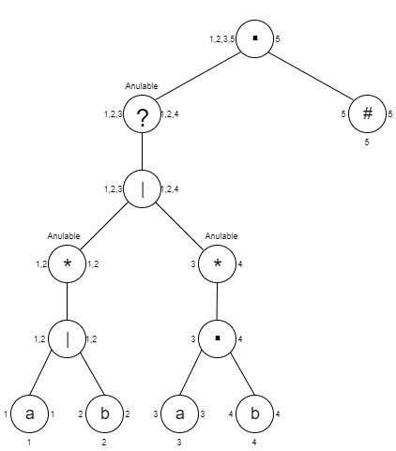

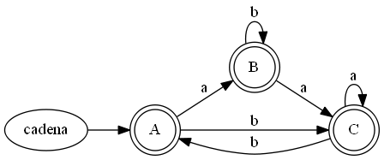

|  |  |
| --- | --- |
|  | Follow |
| 1 – a | 1,2,5 |
| 2 – b | 1,2,5 |
| 3 – a | 4 |
| 4 – b | 3,5 |
| 5 – # |  |

|  |  |  |  |
| --- | --- | --- | --- |
|  | a | b | FDC |
| A = 1,2,3,5 | B = 1,2,4,5 | C = 1,2,5 | Acepto |
| B = 1,2,4,5 | C = 1,2,5 | A = 1,2,3,5 | Acepto |
| C = 1,2,5 | C = 1,2,5 | A = 1,2,3,5 | Acepto |

Ejercicio 3 (a|b)*ba?

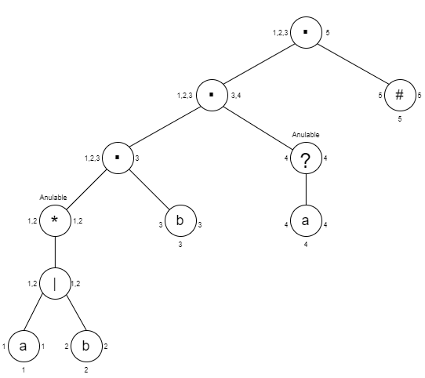

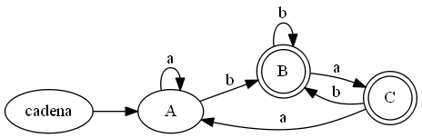

|  |  |
| --- | --- |
|  | Follow |
| 1 – a | 1,2,3 |
| 2 – b | 1,2,3 |
| 3 – b | 4,5 |
| 4 – a | 5 |
| 5 – # |  |

|  |  |  |  |
| --- | --- | --- | --- |
|  | a | b | FDC |
| A = 1,2,3 | A = 1,2,3 | B = 1,2,3,4,5 | - |
| B = 1,2,3,4,5 | C = 1,2,3,5 | B = 1,2,3,4,5 | Acepto |
| C = 1,2,3,5 | A = 1,2,3 | B = 1,2,3,4,5 | Acepto |

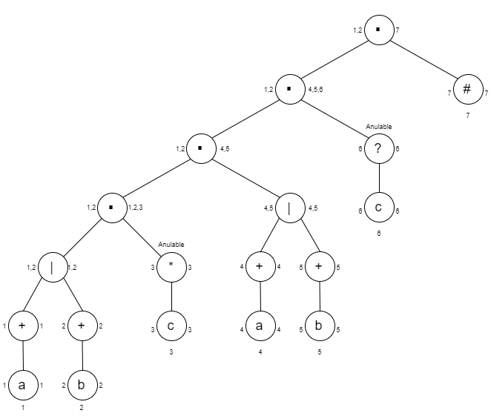Ejercicio 4 (a+| b+)c*(a+| b+)c?

|  |  |  |  |  |
| --- | --- | --- | --- | --- |
|  | a | b | c | FDC |
| A = 1,2 | B = 1,3,4,5 | C = 2,3,4,5 | - | - |
| B = 1,3,4,5 | D = 1,3,4,5,6,7 | E = 5,6,7 | F = 3,4,5 | - |
| C = 2,3,4,5 | G = 4,6,7 | H = 2,3,4,5,6,7 | F = 3,4,5 | - |
| D = 1,3,4,5,6,7 | D = 1,3,4,5,6,7 | E = 5,6,7 | I = 3,4,5,7 | Acepto |
| E = 5,6,7 | - | E = 5,6,7 | J = 7 | Acepto |
| F = 3,4,5 | G = 4,6,7 | E = 5,6,7 | F = 3,4,5 | - |
| G = 4,6,7 | G = 4,6,7 | - | J = 7 | Acepto |
| H = 2,3,4,5,6,7 | G = 4,6,7 | H = 2,3,4,5,6,7 | I = 3,4,5,7 | Acepto |
| I = 3,4,5,7 | G = 4,6,7 | E = 5,6,7 | F = 3,4,5 | Acepto |
| J = 7 | - | - | - | Acepto |

|  |  |
| --- | --- |
|  | Follow |
| 1 – a | 1,3,4,5 |
| 2 – b | 2,3,4,5 |
| 3 – c | 3,4,5 |
| 4 – a | 4,6,7 |
| 5 – b | 5,6,7 |
| 6 – c | 7 |
| 7 – # |  |

